Brain Aligned School & Classroom Discipline

As a classroom teacher and administrator for 25 years working with students that our system has labeled behaviorally disordered the topic of "Discipline" has always been front and center in my mind. Many of our current school systems continue to equate discipline with some form of punishment. This connection has a long and often unconscious tale in our culture.
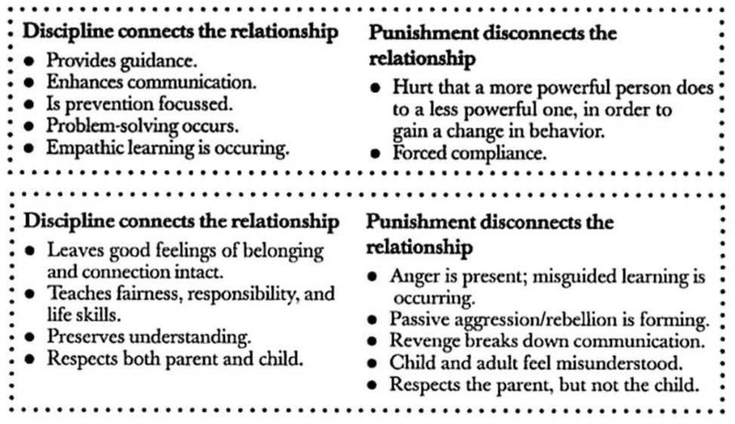
Many teachers leave our field because of classroom "management issues" and schools spend a great deal time literally assigning consequences to students that rarely change BEHAVIOR and often make thing worse!
Many of our university teacher and administrations preparation programs do not really address this critical area of teaching as well and leading schools.
This connection between discipline and punishment could not be more off target and doesn't align with what we currently know from the world of neuroscience. We must stop perpetuating the myth that discipline and punishment ( or "consequences" ) must happen when young people "mis-behave".
Lets define discipline.........
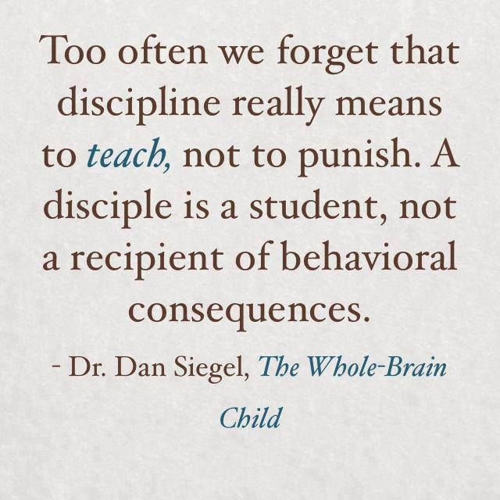
Let me be clear- Discipline is essential to schools, classrooms and learning. It includes setting up clear and consistent boundaries as well and clear expectations for the young people we serve and who are in our care.
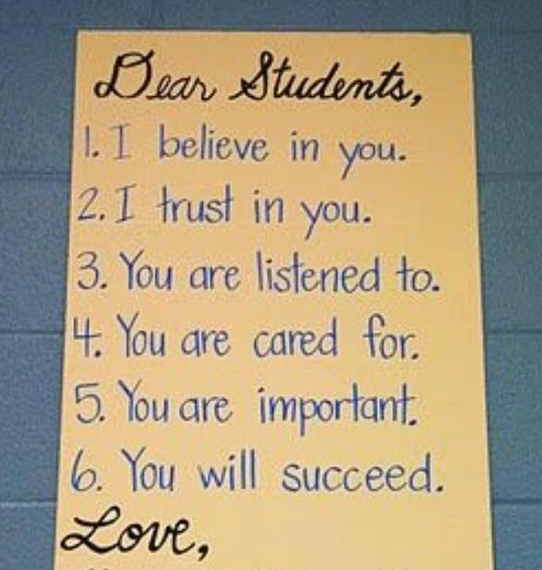
Effective discipline depends on creating and maintaining positive connections with all your students.
Adults must forge this connection and protect it!! It is absolutely critical that we, the adults, model respect and treat the young people in our care with a high degree of dignity and respect at all times, especially when things are not going well!! ( Without this connection know that you have entered a war of attrition, that has winners, and everyone losses. )
Discipline should never be done in public and should not include threats or humiliation, cause physical pain, scare children, or make them feel that the adult is the enemy. Discipline should feel safe and the adult needs to be in control of themselves.
Remember: CALM IS STRENGTH----UPSET IS WEAKNESS! When adults get upset and start to "downshift" everyone loses!!!
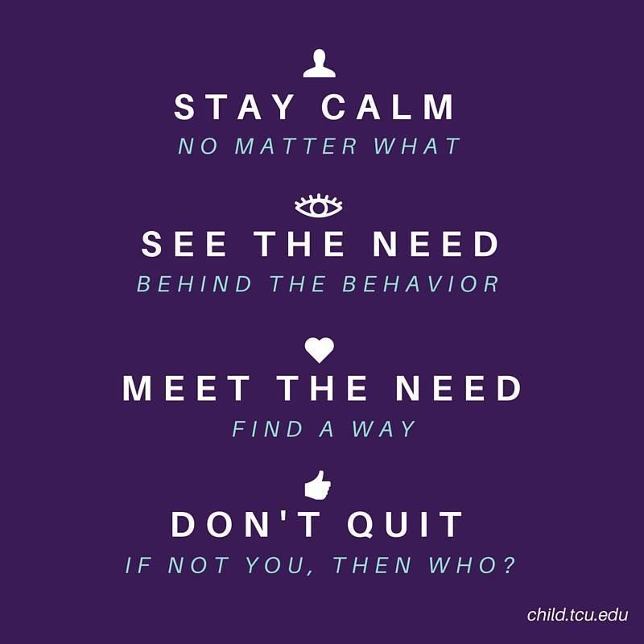
This is a brain aligned strategy not a fairy tale.
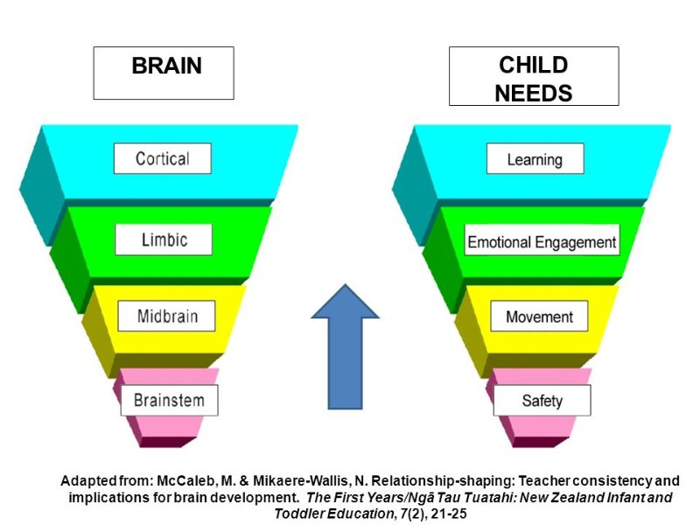
Upset students are not in the "Thinking Part" (Executive State ) of the brain and until they are, nothing we can do will have a positive outcome. If adults join the young people and "downshift" to a lower brain state, nothing good happens!!!
#1 Rule- Both parties need to be in the executive state of their brains to "problem solve" and to "TEACH". This is true in academics as well as the behavioral and social domain.
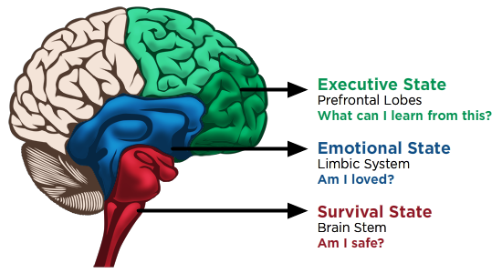
The goal of discipline is to teach. ( Dan Siegel & Tina Byson )
Begin to think of discipline much differently. See them as a chance to teach and to problem solve! We want to leave the "discipline interaction" with a positive feeling and build young people’s skills in how to handle themselves ( self-regulation) and how to make better choices in the future.
This is really important teaching!!!
STEP #1- EMOTIONAL FIRST AIDE-
Adults need to first recognize that emotions drive behavior. We need to first make sure that we are aware and validate the "FEELINGS" behind the surface behaviors we see.
Our first job is to help them calm down, so they can regain control and handle themselves well. Teachers and administrators can learn the critical skill of validation!
Validation works to UP-SHIFT BRAINS TOWARD THE EXECUTIVE STATE.
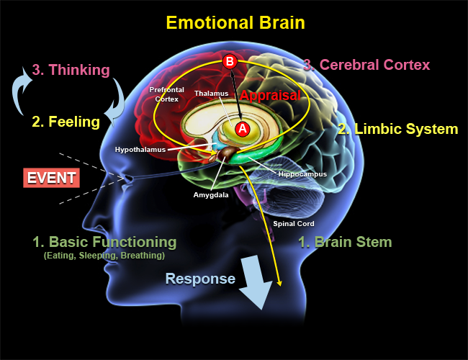
Science has shown that addressing kids' emotional needs is actually the most effective approach to changing behavior over time, as well as developing their brains in ways that allow them to handle themselves better as they grow up. - Dr. Dan Siegel
Remember when kids are at their worst that is when they need us the most!!!
Think of this time as an excellent chance to be there for them, help them to calm down ( co-regulation ) and put themselves back together. This is how you build TRUST & SAFETY WITH KIDS!!!
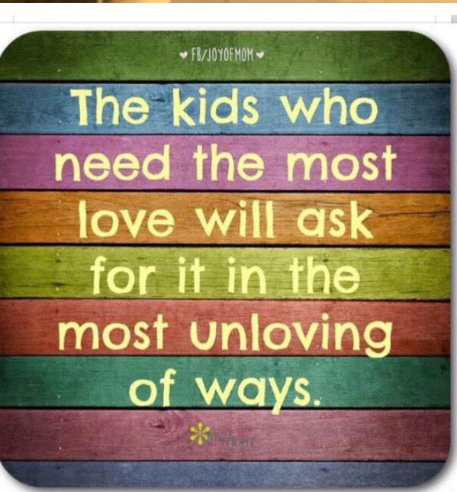Before we deal with their behavioral choices and help them to make better ones in the future we need to CONNECT WITH THEM! We connect by helping them calm down not by yelling and threatening them!
So... rather than the typical sequence of: NAG--THREATEN--PUNISH
THE BRAIN ALIGNED DISCIPLINE SEQUENCE GOES LIKE THIS:
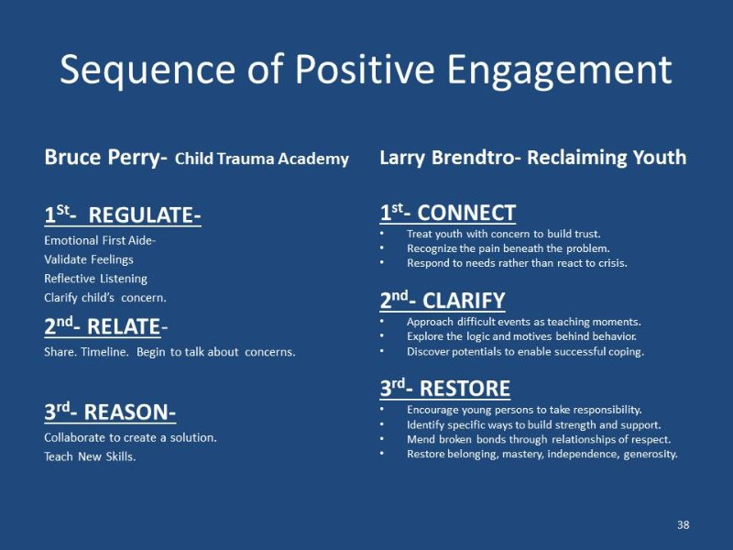At the end of this sequence we do not need to give them an experience to try and make them feel bad about what they did. Not brain aligned! Coercion or fear based discipline systems do not change behavior. It simply goes underground.
As we work with kids we use these opportunities to teach, reteach and help young people gain insights into themselves and the kind of people they want to become! We also want them to learn empathy and the motivation and ability to restore things after they have made a mistake!
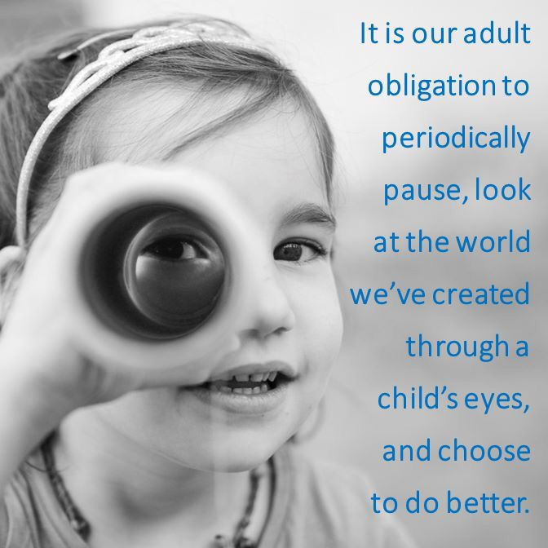Do let me know what you think!!
ShareShare Brain Aligned School &amp;amp; Classroom Discipline
- LikeBrain Aligned School & Classroom Discipline
- Comment

